FAST NUCES

Shayan Anwar 21K-4836

DevOps Assignment:

Static Website hosting using S3 Bucket:

Website url: <http://devassignmentbucket.s3-website-us-east-1.amazonaws.com>

Bucket Properties:

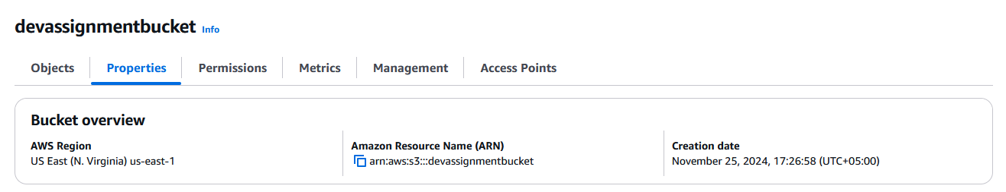

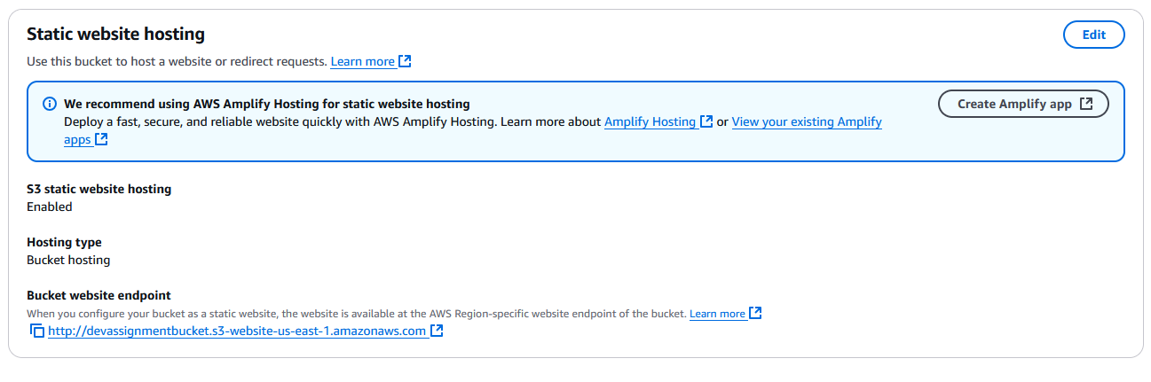

When Opening Url:

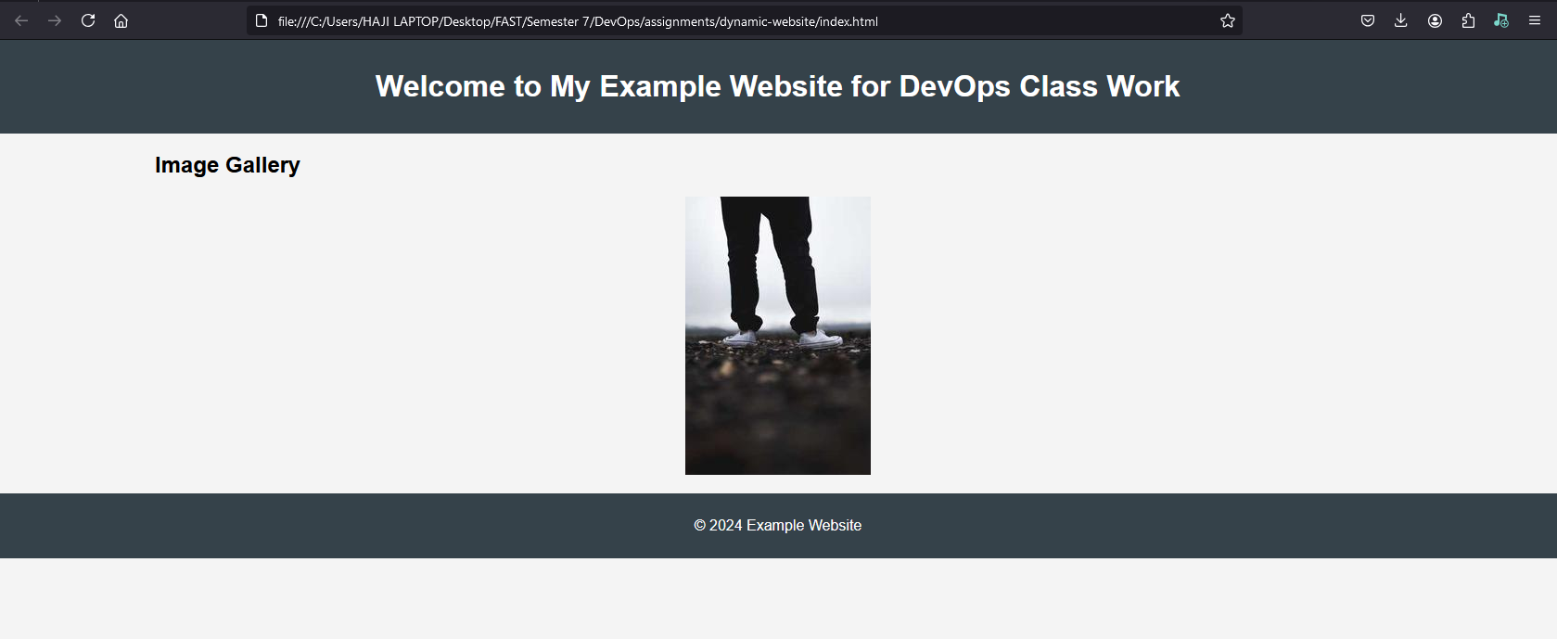

Dynamic App Using Github:

The app is essentially a redirect to a website.

IAM User with full access to S3, CodeDeploy, CodeBuild, CodeCommit and ECS

Credentials: username “assignment” password “k[oR4]8|”

Installing Git locally:

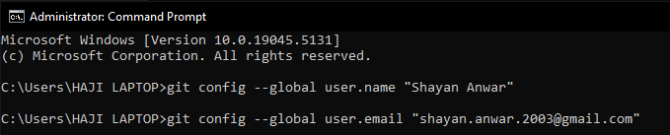

Initializing Git and creating repository followed by initial commit (branch is Master)

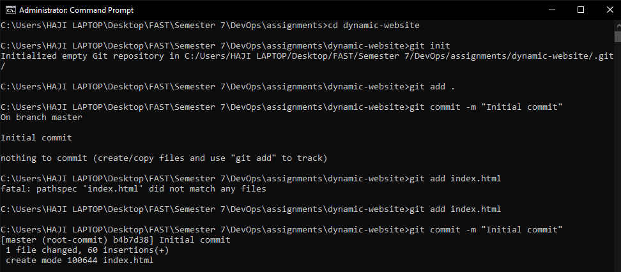

Index.html uploaded to the repository

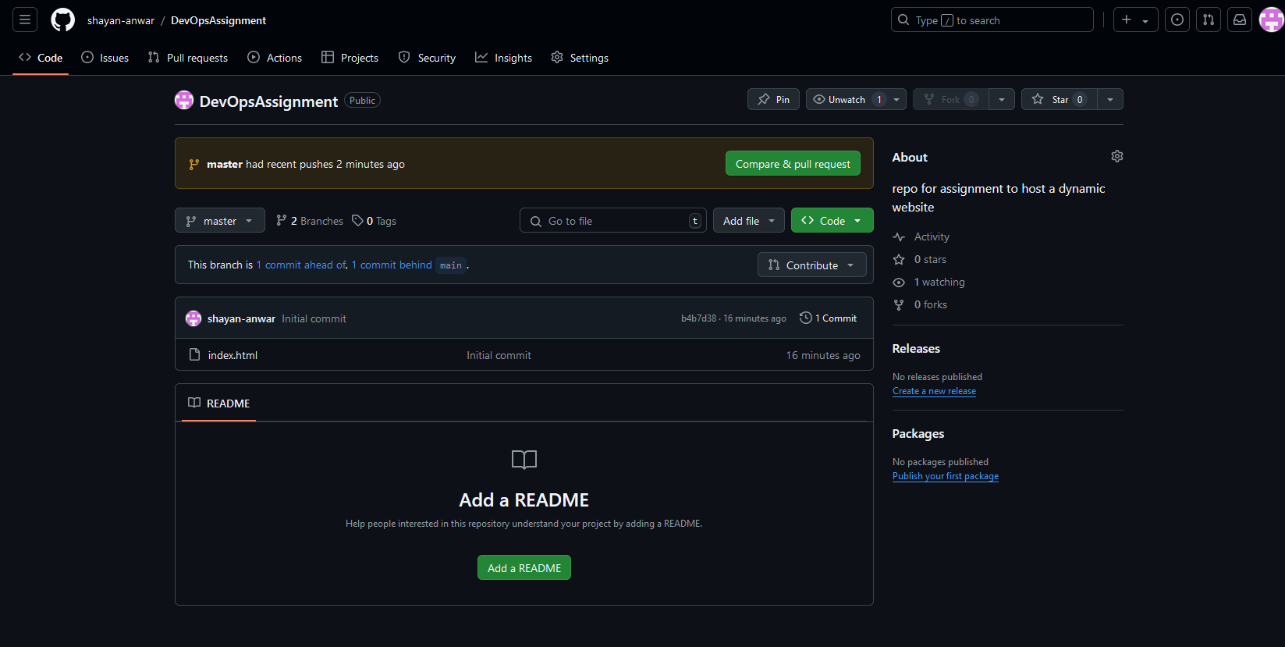

Pushing files for dynamic website in repository:

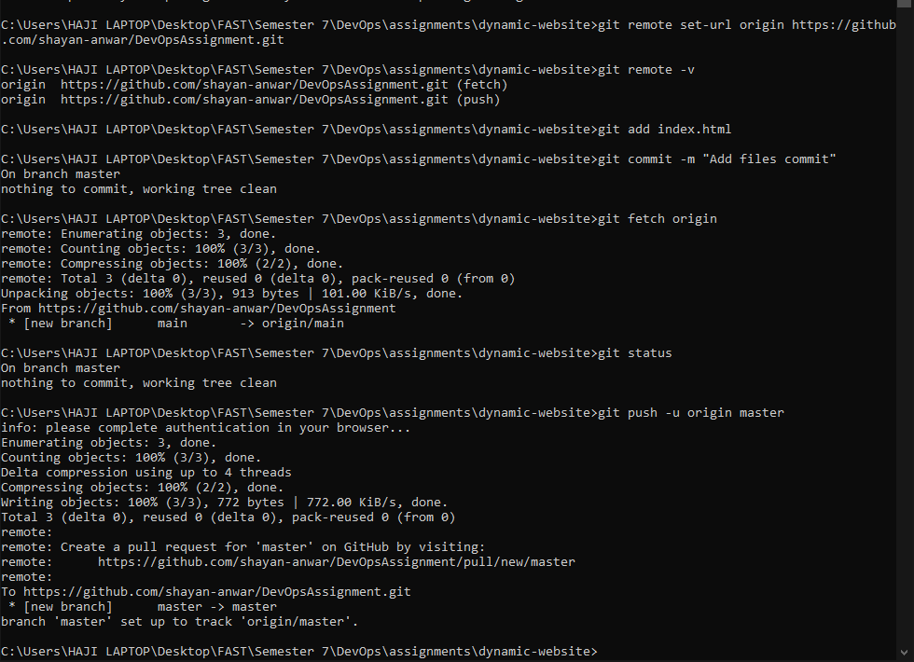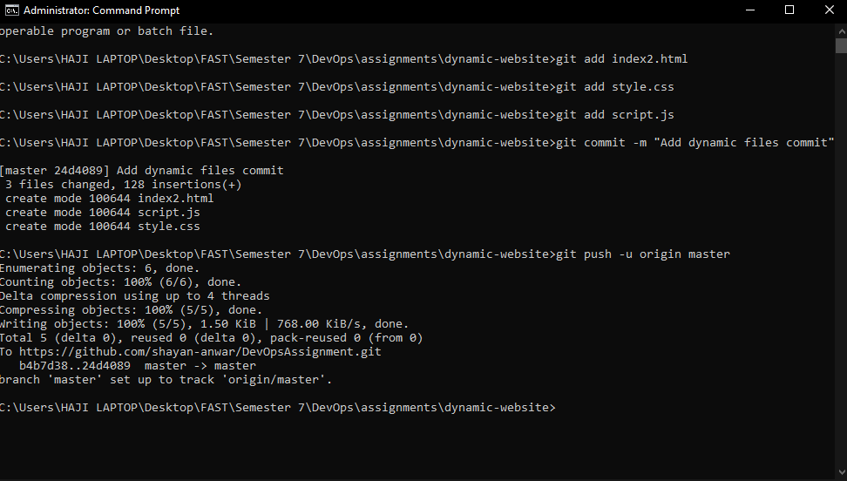

Authenticating the push:

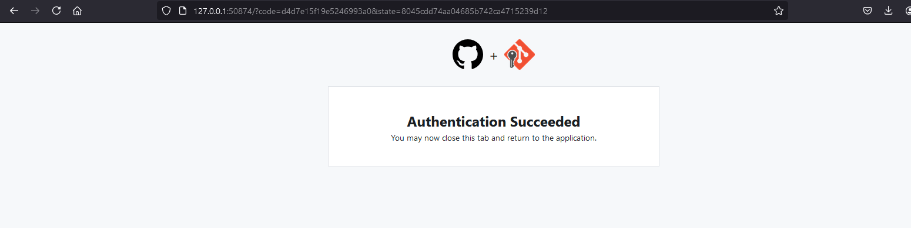

After configurating our project build via CodeBuild, we started the build and it succeeded

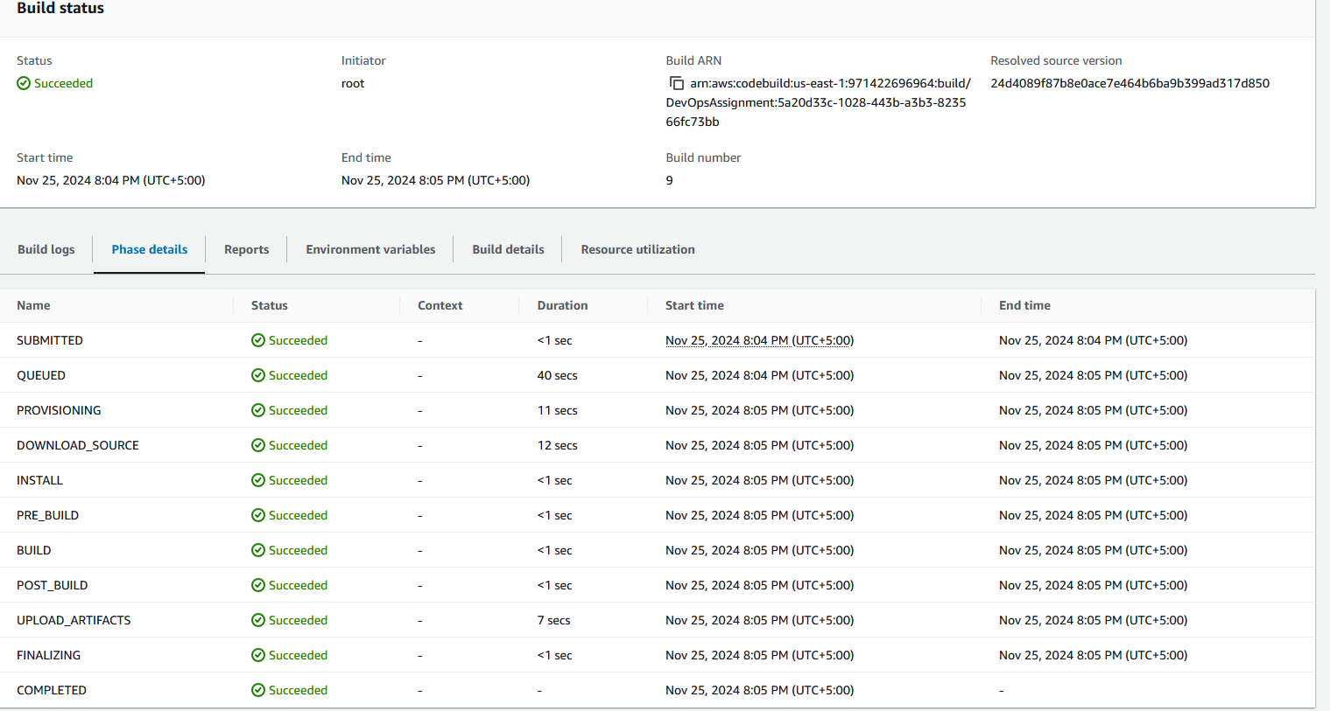

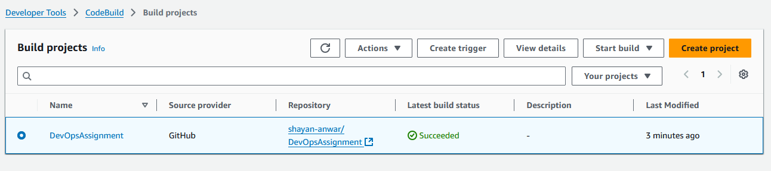

Now we can access the dynamic website and use it

